Jinan Zhongtian International Trading Co.,Ltd.
Add : Y2-1320. Wanda Plaza. High-tech Zone, jinan city. shandong. china
Mobile:+86 13075302088 Tel:+86 531 88890369 Email:judy@chinalifter.cn
Trailer Mounted Boom Lift

 | Project | performance parameter
1 | Platform size | 900*700mm
2 | Loading capacity (kg) | 200
3 | Worker | 2
4 | Platform height mm | 10000
5 | Working height mm | 12000
6 | Working radius mm | 5100
7 | Whole machine length mm | 6645
8 | Whole machine width mm | 1650
9 | Minimum platform height mm | 2050
10 | Oil cylinder | Hebei Hengyu
11 | Power producer v/kw | 380V/2.2kw | standard configuration
11 | Power producer v/kw | Selection, power： | Diesel engine, gasoline engine | 220V 50hz
11 | Power producer v/kw | Selection, power： | Batteries  4pieces 6V230ah
12 | Driving model | External force traction
13 | Rotation angle | 359°
14 | Hydraulic leg | Automatic telescopic Independently adjustable
15 | Tire | 225-70R15C
16 | control system | Upper and lower control, set manual emergency descending valve
17 | Self-weight kg | 1900
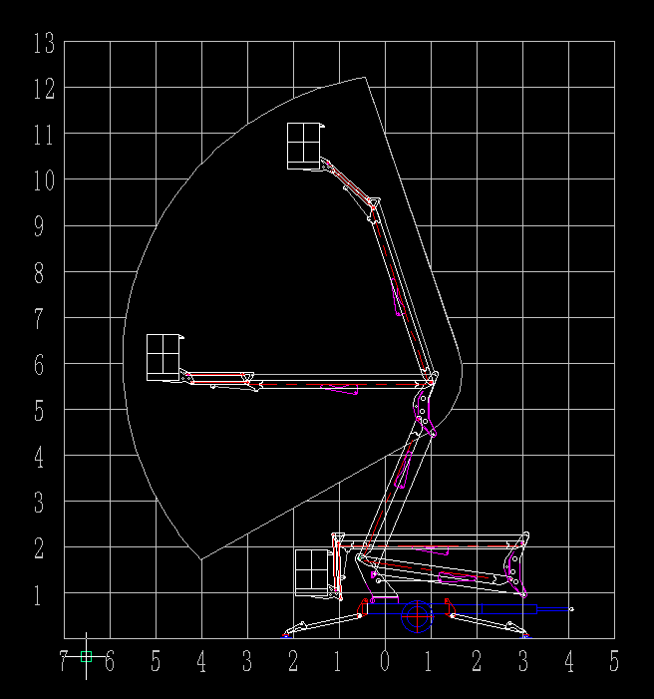

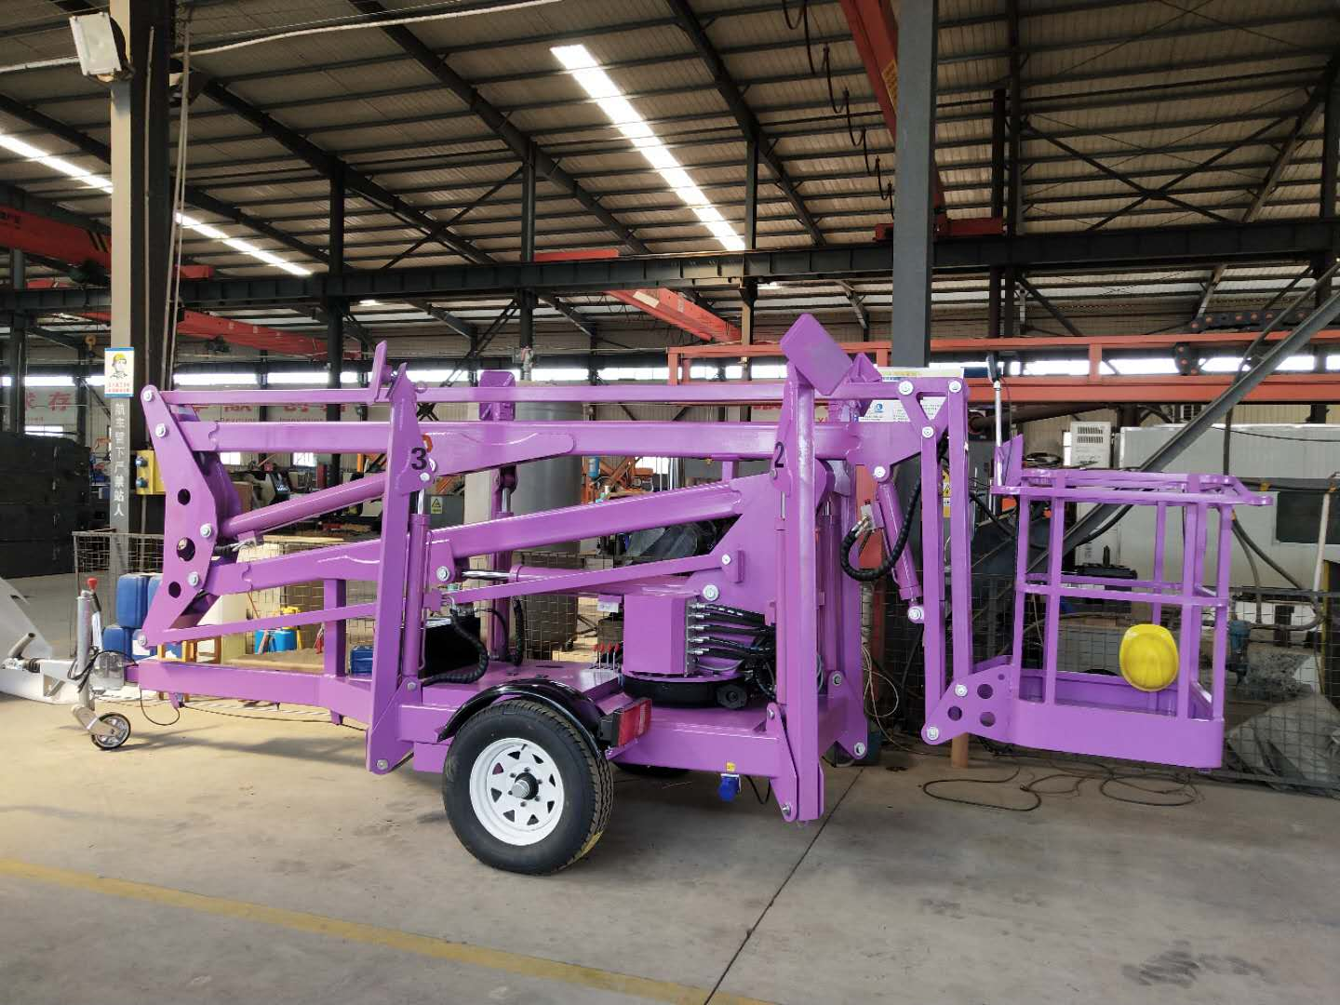

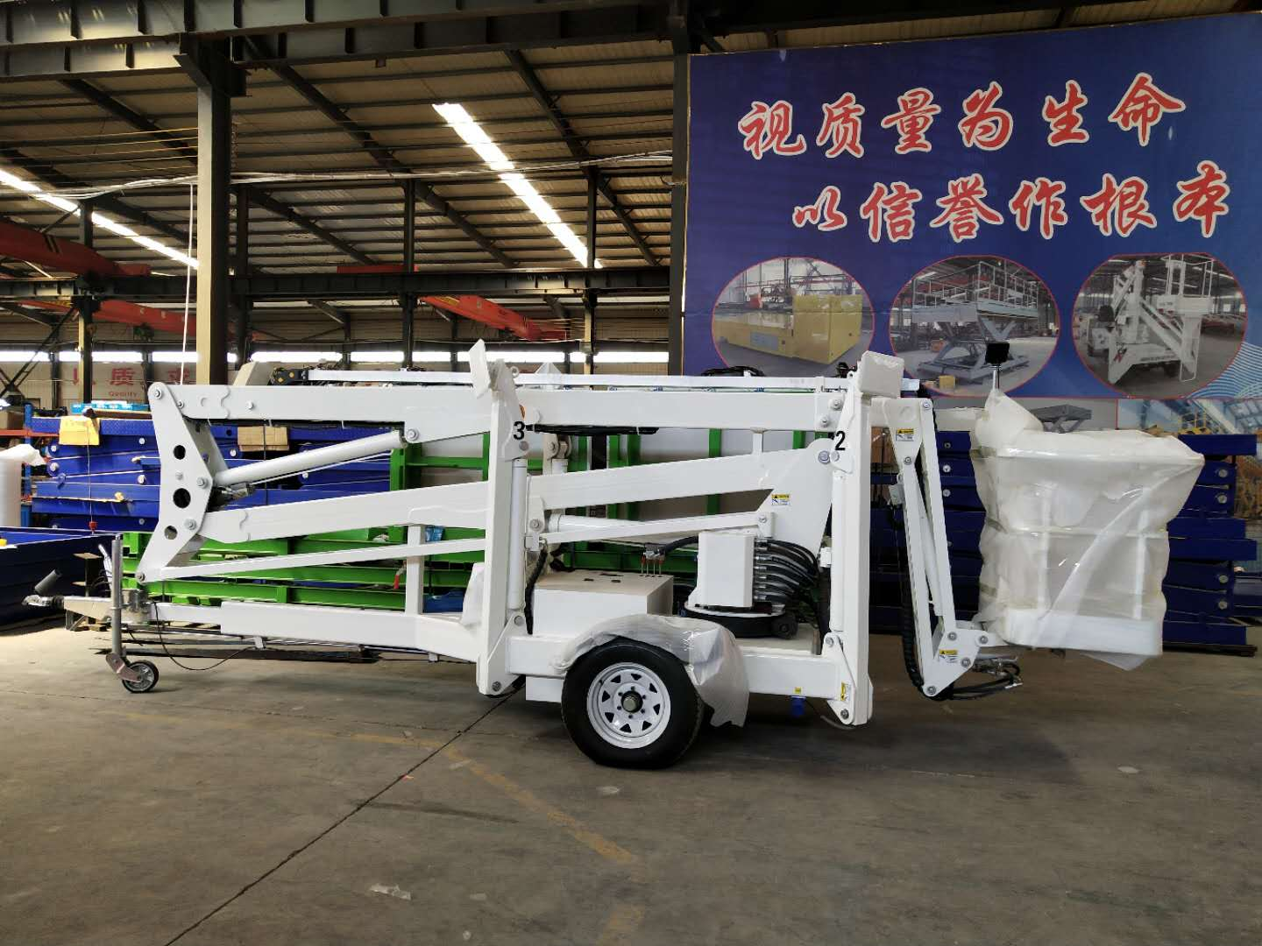
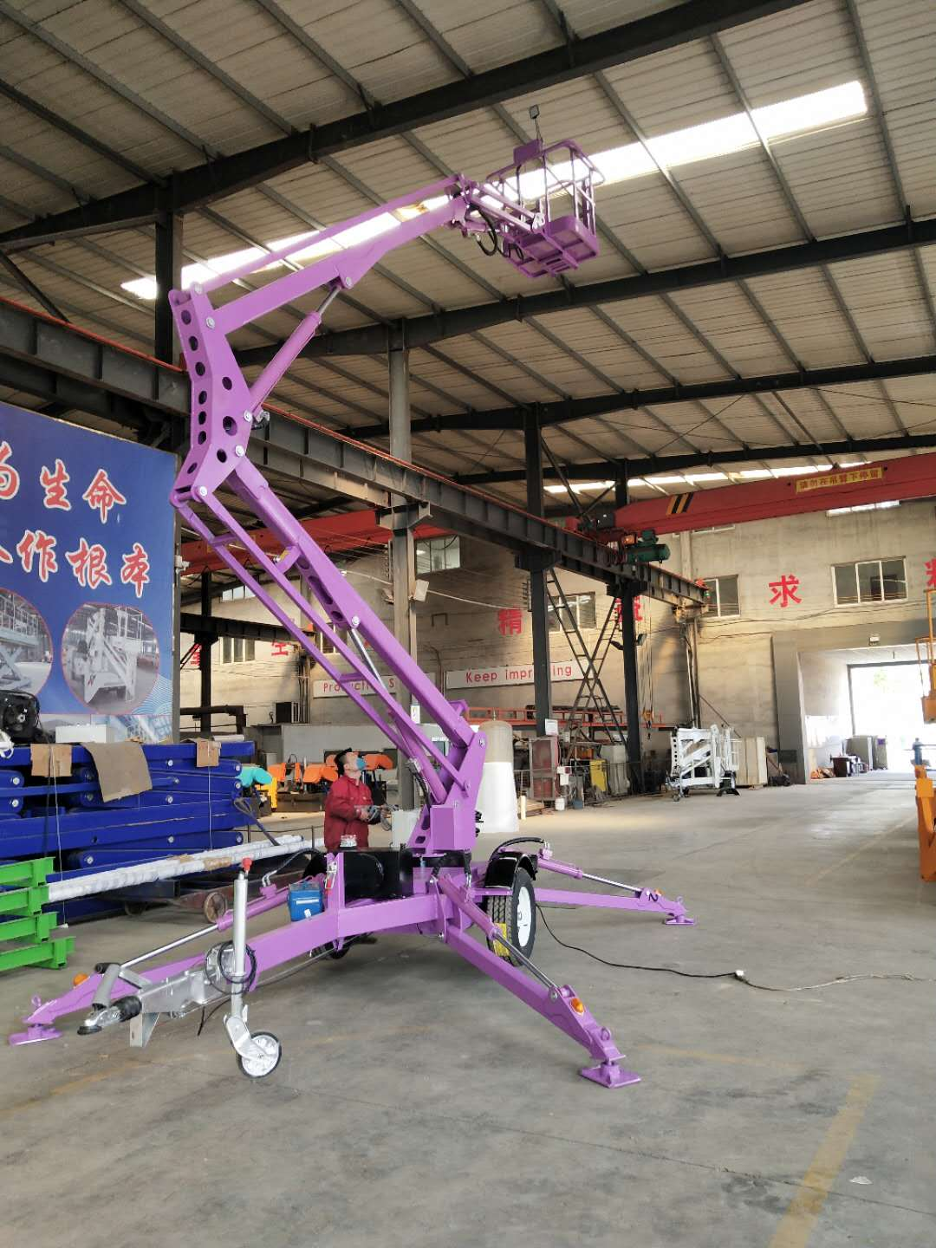

Advantages:
ZYTP trailer lifting platform, lifting work table can be raised and can be extended horizontally and adjusted up and down, the equipment can also be rotated.Easy to reach the working position over obstacles, widely used in all kinds of construction, maintenance, high-altitude cleaning, garden pruning, high-speed maintenance and other industries is an ideal elevator for work.

Safety protection:
(1) the hydraulic system is equipped with anti-explosion device (when the hydraulic pipe bursts, the explosion-proof device starts and the platform stops falling);
(2) equipped with leakage protection device to ensure the safety of the operator;
(3) each section of the rod above the emergency drop valve, if there is a problem with the equipment, emergency drop can be used.
(4) the traction system imported from Italy, the brake is more sensitive.
(5) the use of torque shaft design torque shaft balance degree of good spring.When the ground is uneven, automatically level.After electrification, with electromagnetic brake.

