Dock Leveler load 15tons configuration parameters
List of materials for 15 ton dock leveler
Serial Number Part Name Specification Model Material Remarks (Supplier)
1 Panel size 2500×2000×8mm checkered plate Q235
2 Main beam 150×75×5mm rectangular tube Q235 Shandong Zibo Lubao
3 Auxiliary beam 150×75×5mm rectangular tube Q235
4 Mainboard shaft sleeve 45# seamless pipe, φ45, quenched and tempered 45# Laiwu Steel
5 Main board shaft pin 45# round steel, φ45, quenched and tempered 45# Laiwu Steel
6 Tongue plate 1980×390×24mm Firmly welded Q235 flat plate 20mm + checkered plate 4mm
7 Hinge lug plate 10mm Q235 Jinan Iron and Steel
8 Underframe Rectangular tube 150*75*5 Q235 Zibo Lubao, Shandong
9 Skirt plate 2.5mm Q235
10 Bracket cylinder, Bore Ф80 Jinan Huataili
11 Tongue cylinder Bore Ф40 Jinan Huataili
12 Power unit Yidhepu Pumping Station
13 Hydraulic tubing rated pressure 16Mpa-I-Ф10 double-layer steel mesh Aolong (Rubber Fourth), Jing County, Hebei
14 Hydraulic oil Kunlun hydraulic oil Jinan Kunlun hydraulic oil
15 Control Electrical Delixi Jinan Delixi Sales Center
16 Surface treatment Shot blasting Paint baking
17 Drive motor 380v/2.2kw
18 Sealing ring imported from Japan NOK
19 Working table stroke (mm) Upward 400mm, downward 300mm Minimum height of equipment: 600
20 Working pressure ≤16Mpa
21 Anti-collision pad Solid rubber anti-collision block Rubber
22 Operation control The whole set of actions of this fixed boarding bridge (upward, horizontal, and downward have buttons to complete)
23 Lip plate shaft sleeve 45# seamless tube, φ45, quenched and tempered 45# Laiwu Steel
24 Lip plate shaft pin 45# round steel, φ28, quenched and tempered 45# Laiwu Steel

Packaging and Shipping

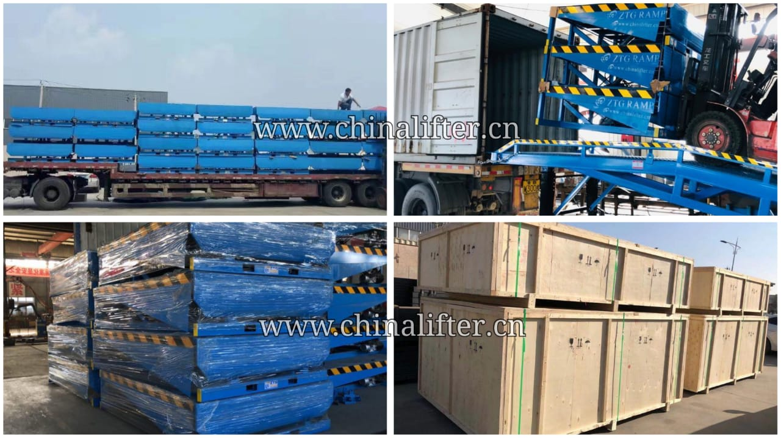

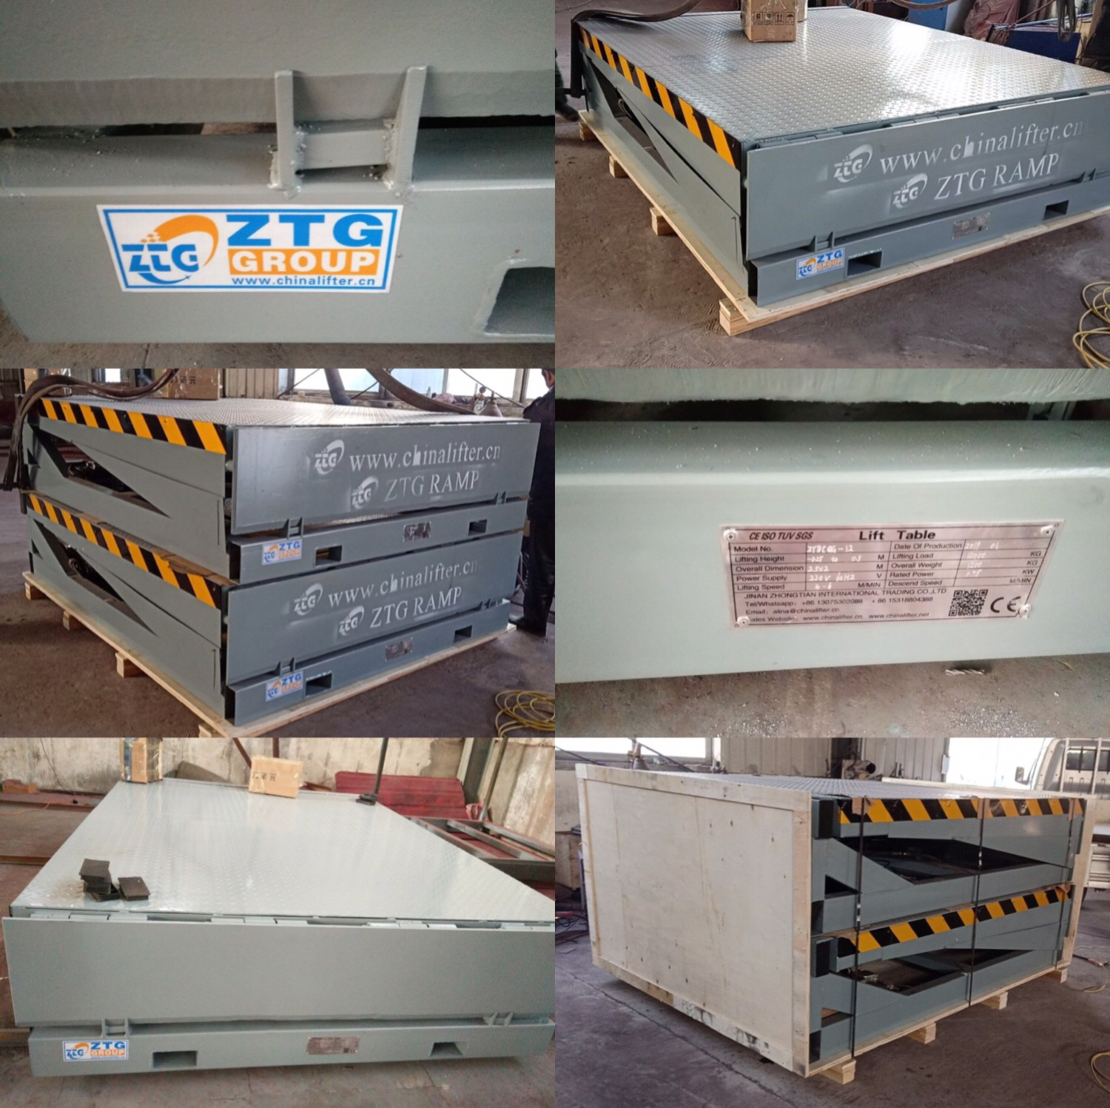

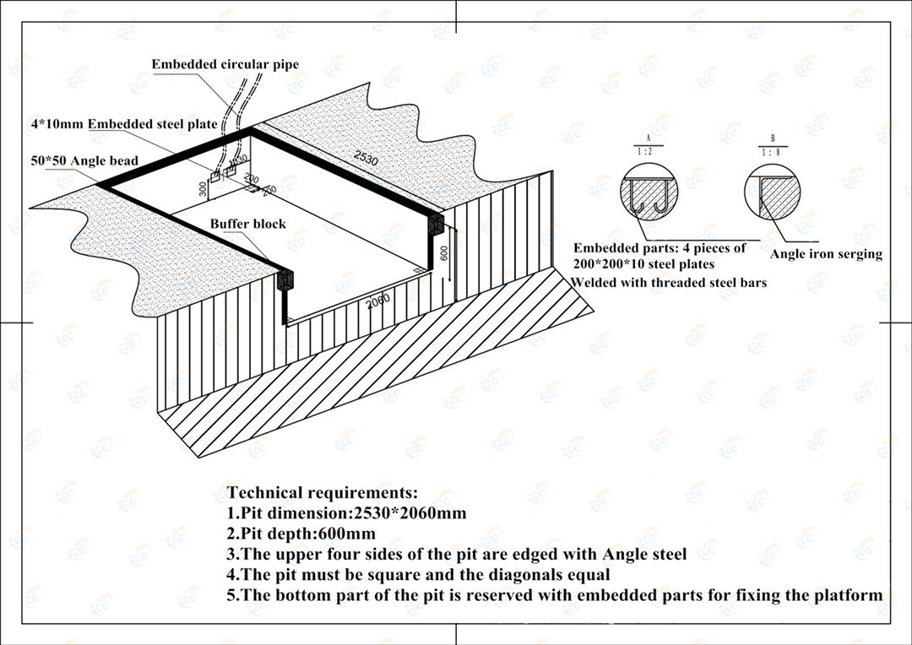
Installation Site Pit Drawing
Customers visit the factory:

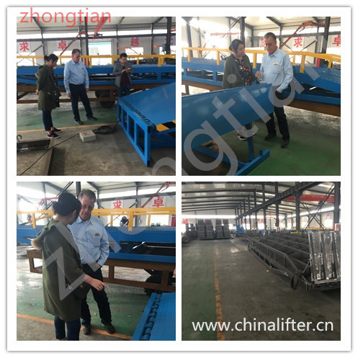

Installation Site Pit Drawing
Related Products

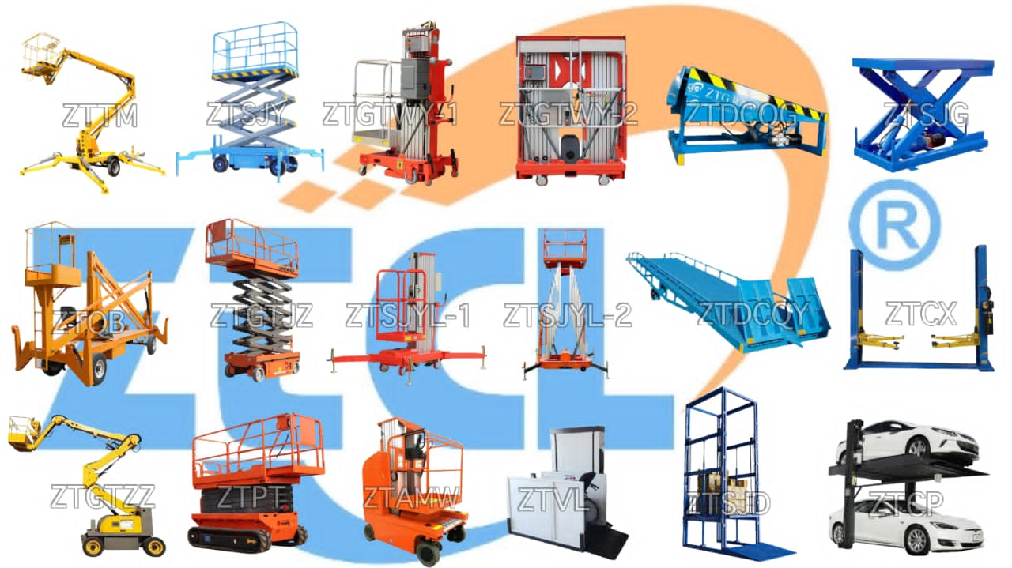

Certificate:
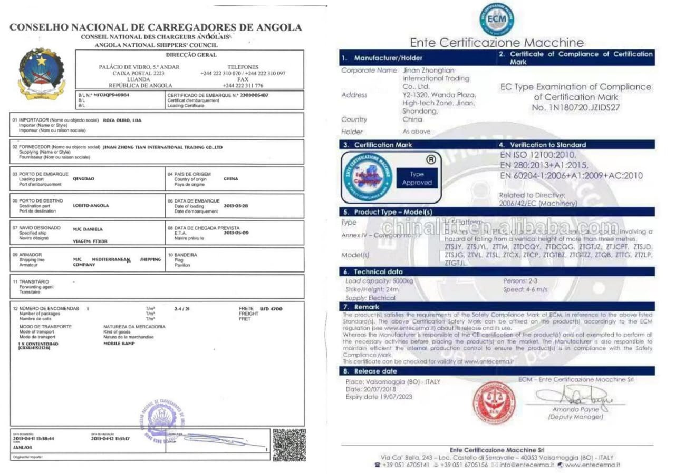
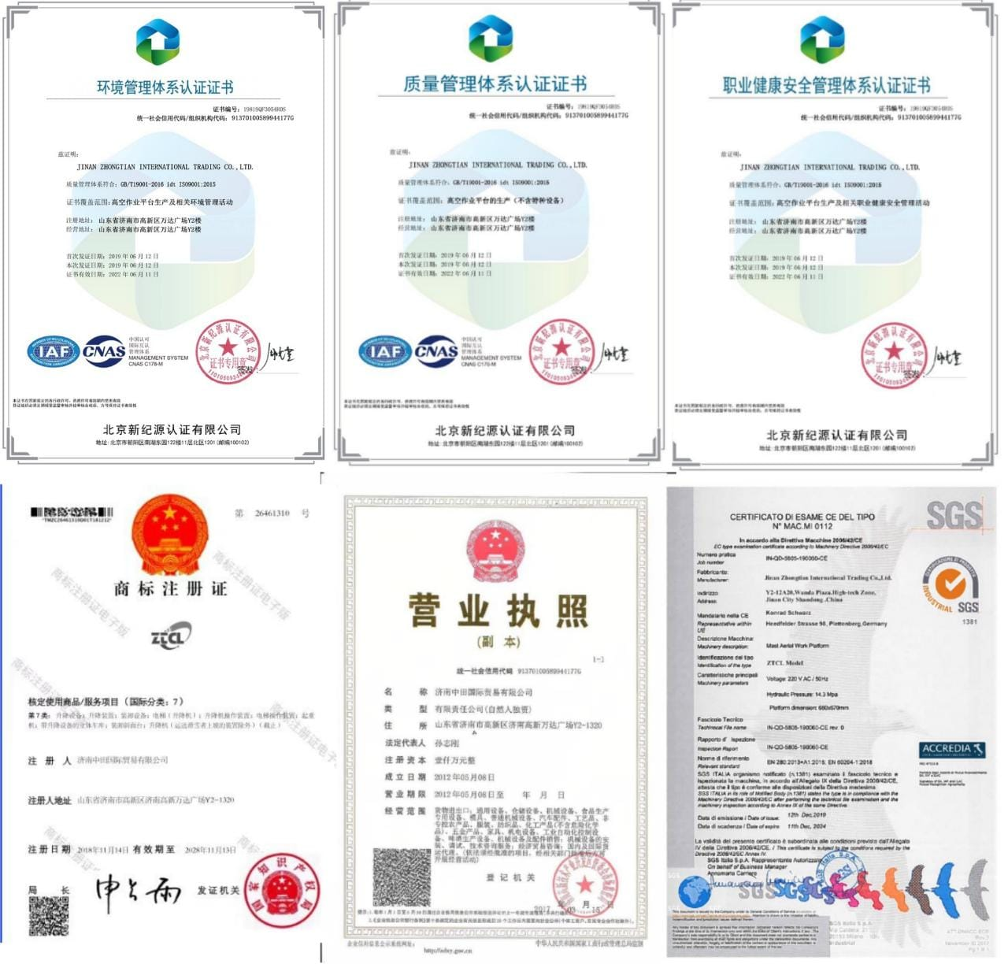

Follow our links: ( Click on Photo to Follow the Link )
 Website  Instagram  Facebook  Youtube

